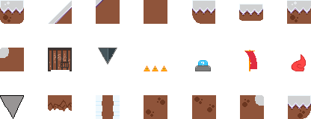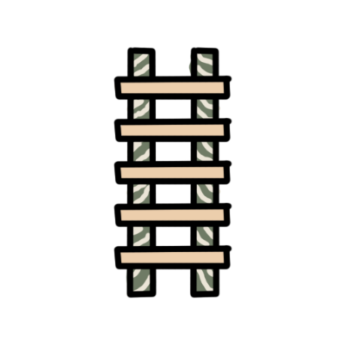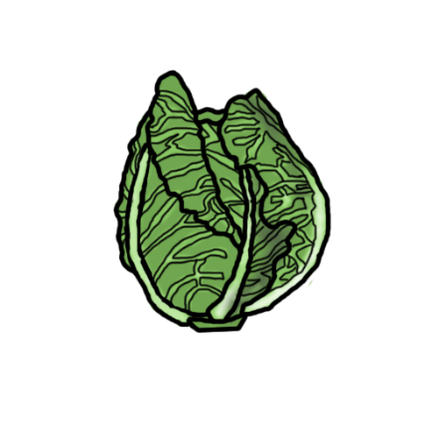
These are some of the props and tiles used in the levels as the player progresses throughout the game. We wanted to relate certain items to the theme of our game so we researched into different aspects of our characters and various Japanese items. The cabbage which rabbits eat serves as the lives of the player and snow as the players MP (Magic points) to jump higher or run faster.
The cabbage was originally supposed to be the players health but we changed it to lives as it was easier to blueprint into the game.

